Ethan Allen Outdoor Bench Warmer

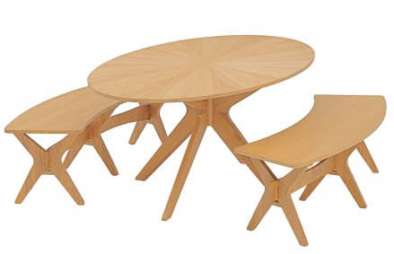

|  |
| --- |
| **DESCRIPTION** |
| Ethan Allen introduces stylish round shaped table with round long benches. Natural Formica mixed with carbon fiber makes it easy to make a strong outdoor dine bench with a set of tables and benches it is made perfect to create the perfect look for family outing. The rich wood with round table and back less benches gives it more room for people to sit and relax. Perfect for you and your family. |

|  |  |  |
| --- | --- | --- |
| **Price** | **950$** | |
| **Dimensions** | **Table H** x **W** x **L** | **30in x 28in x 40in** |
| **Benches H** x **W** x **L** | **25in x 28in x 20in** |
| **Features** | **Two benches and One Table with Formica embedded with carbon fiber prove to make this set stronger than steel and perfect for weather conditions.** | |
| **Finished** | **Peach Brown polish** | |
| **Available in** | **Peach and Brown** | |